Altmetric

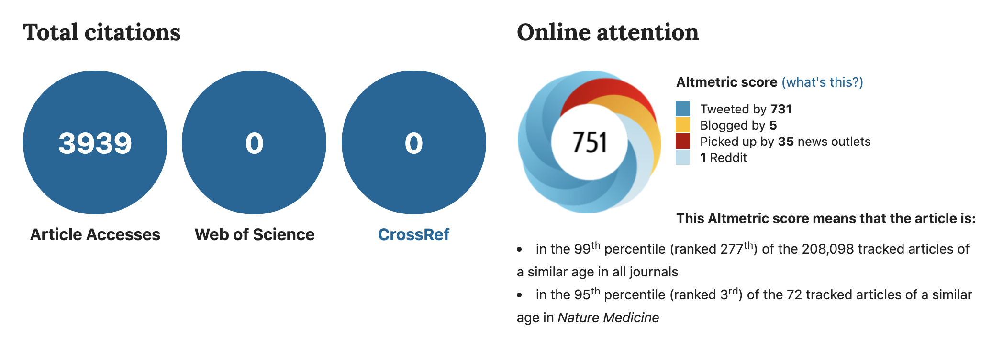
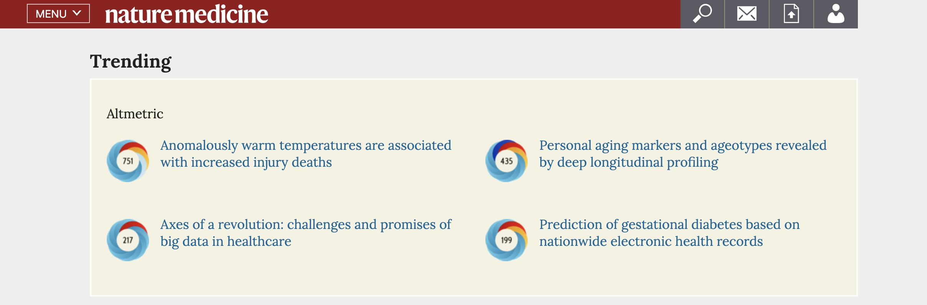Tweets

Tweeted by Greta Thunberg, David Wallace-Wells, [[[TO FINISH]]]

Coverage for paper

JAN 23

Violence, suicides, noyades, blessures: le nombre de morts pourrait augmenter à cause du changement climatique
La Libre, 23 Jan 2020

JAN 16

Calor anormal pode aumentar lesões fatais. Homens são os mais afetados
TSF, 16 Jan 2020

Changement climatique: la hausse des températures pourrait entraîner une augmentation de décès chez les 15-34 ans
RTBF, 16 Jan 2020

Il riscaldamento globale farà aumentare gli incidenti stradali e gli infortuni (VIDEO) - Greenreport: economia ecologica e sviluppo sostenibile
Green Report (Italy), 16 Jan 2020

Hotter Temperatures Could Kill 2,000 More A Year In US: Study
Dailyhunt, 16 Jan 2020

JAN 15

Rising temperatures could increase injury deaths by 2,000 a year: study
Smart Cities Dive, 15 Jan 2020

Injury Deaths Predicted to Increase With Anomalously Warm Temperatures
Doctor’s Lounge, 15 Jan 2020

Injury Deaths Predicted to Increase With Anomalously Warm Temperatures
Physician's Briefing, 15 Jan 2020

Injuries and Deaths Could Rise with Climate Change in the U.S., a New Study Finds
TIME – Jan 15, 2020

Injuries and Deaths Could Rise with Climate Change in the U.S., a New Study Finds
Yahoo! News, 15 Jan 2020

Climat : la hausse des températures augmenterait les décès des 15-34 ans
Futura-Sciences, 15 Jan 2020

Climat : la hausse des températures augmenterait les décès des 15-34 ans
Free, 15 Jan 2020

Cases of injuries and deaths might increase due to climate change: Study
New Kerala, 15 Jan 2020

How climate switch would possibly perchance maybe well maybe merely elevate the suicide rate, cancel 2,000 extra folks a year
Invest Records, 15 Jan 2020

JAN 14

Daily Briefing
Carbon Brief, 14 Jan 2020

Climate change will increase injuries and deaths in USA
The Medical News, 14 Jan 2020

Rising temps could cause as many as 2,100 fatal injuries per year
sb Dirty South Soccer, 14 Jan 2020

From car accidents to alcohol consumption, researchers say rising temperatures could lead to thousands of deaths
StocksMarket.in, 14 Jan 2020

From car accidents to alcohol consumption, researchers say rising temperatures could lead to thousands of deaths
Morning Star, 14 Jan 2020

Глобальное потепление может увеличить количество смертей от несчастных случаев
Medportal, 14 Jan 2020

Climate Change May Translate Into More Fatal Injuries
Medicinenet, 14 Jan 2020

Rising temps could cause as many as 2,100 fatal injuries per year
Breitbart – Jan 14, 2020

The Heat is On: ‘rise in violence’ as planet warms [[I have pdf]]
Daily Star – Jan 14, 2020

How climate change could change the way we die
Anthropocene – Jan 14, 2020

News story from Gizmodo Australia on Tuesday 14 January 2020
Gizmodo Australia, 14 Jan 2020

Car accidents, drownings, violence: Hotter temperatures mean more deaths
World News SBS, 14 Jan 2020

Hotter temperatures will lead to more deaths from injury
Eco Business, 14 Jan 2020

Warmer temperatures linked to increase in US injury deaths, study says
KVIA, 14 Jan 2020

Suicides and drownings: New study lays out the surprising ways a hotter climate will kill Americans
The Raw Story, 14 Jan 2020

JAN 13

Climate crisis likely to increase violent deaths of young people – report
The Guardian, 13 Jan 2020

¿Más ahogamientos, suicidios y atracos? la crisis climática podría estar aumentándolos | ELESPECTADOR.COM
El Espectador, 13 Jan 2020

Climate Change Could Lead to More Injuries and Deaths
Inside Climate News, 13 Jan 2020

Rising temps could cause as many as 2,100 fatal injuries per year
UPI – Jan 13, 2020
(wire service report; widely syndicated)

Car accidents, drownings, violence: hotter temperatures will mean more deaths from injury
The Conversation, 13 Jan 2020

Climate crisis likely to increase violent deaths of young people – report
Yahoo! News, 13 Jan 2020

Global Warming Could Kill Thousands of Americans a Year With Drowning, Assault, Suicide
Daily Mail (UK) – Jan 13, 2020

Rising Temperatures May Cause Over 2,000 Fatal Injuries Per Year in the US, Predict Researchers
Medical Xpress – Jan 13, 2020

Climate-Change Related Injuries Will Kill Thousands in the US
New Scientist (UK) – Jan 13, 2020

Climate Change May Translate Into More Fatal Injuries
Healthday – Jan 13, 2020

Just 1.5 Degrees of Warming Could Kill 1,600 More Americans Each Year
Newsweek – Jan 13, 2020

A Hotter Climate Will Kill Americans in Unexpected Ways, Says Study
Gizmodo – Jan 13, 2020

Climate Change Could Lead to More Injuries and Deaths
The Verge – Jan 13, 2020

Warmer Temperatures Linked to Increase in US Injury Deaths
CNN – Jan 13, 220

New Study Lays Out the Surprising Ways a Hotter Climate Will Kill Americans
Rawstory – Jan 13, 2020

Rising temperatures may cause over 2,000 fatal injuries per year in the US, predict researchers
MedicalXpress, 13 Jan 2020

Rising temperatures may cause over 2,000 fatal injuries per year in the US, predict researchers
EurekAlert!, 13 Jan 2020

Injuries and Deaths Might Increase Due to Climate Change: Study
ANI (India) – Jan 13, 2020
(wire service report; widely syndicated)

Rising Temperatures Could Cause More Than 2,000 Deaths a year in the U>S>
EFE (Spain) – Jan 13, 2020
(wire service report; widely syndicated)

Climate science: Impacts of global heating on US deaths from injuries assessed(Nature Medicine)
Research Highlights, 13 Jan 2020

